CS 255 System Design Document Template

UML Diagrams

UML Use Case Diagram

The use case diagram below models the DriverPass system and identifies five actors: four human actors (Owner, Administrator, Employee (Secretary), and Customer) and one external system actor (DMV). The DMV is modeled as an actor rather than a use case because it initiates communication with the system independently, sending compliance updates whenever new rules, policies, or sample questions are released.

The use cases are organized around five functional areas: reservation management, training and course content, authentication, administrative functions, and DMV compliance. Authentication is modeled as an included use case via an `<<include>>` relationship, since every transaction requires the user to be logged in first. Each use case in the diagram, with the exception of Send Compliance Update and Reset Password, is connected to Authenticate User via an explicit <<include>> relationship, represented by dashed arrows with open arrowheads pointing toward the included use case. This reflects the requirement that every user transaction requires successful authentication before proceeding.

UML Activity Diagrams

Two activity diagrams are provided below, one for the Authenticate User use case and one for the Make Reservation use case . These two flows were selected because they represent the most critical paths through the system: nearly every user action depends on successful authentication, and reservation management is the primary operational function of the DriverPass platform.

Activity Diagram 1 — Authenticate User

This diagram models the login flow for all user roles. The flow begins when a user submits credentials and branches based on validation outcome. A failed attempt increments a counter; once the defined threshold of consecutive failures (3) is reached, the account is locked and the administrator is notified. A successful login directs the user to their role-appropriate interface: the Owner dashboard, the Administrator account management panel, the Secretary reservation management view, or the Customer portal.
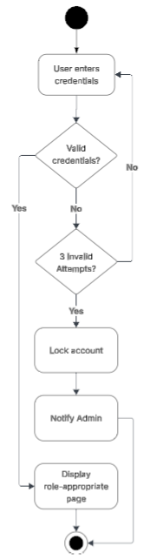

Activity Diagram 2 — Make Reservation

This diagram models the flow from a customer or secretary selecting a driving lesson time slot through to booking confirmation. The flow includes two decision nodes: whether the user confirms the reservation after reviewing the pickup and drop-off locations, and whether the selected time slot is still available at the time of confirmation. If the time slot is no longer available, the user is notified immediately. On successful booking, the system assigns a driver and vehicle, saves the reservation, and logs the transaction with a timestamp and the identity of the user who made the booking.
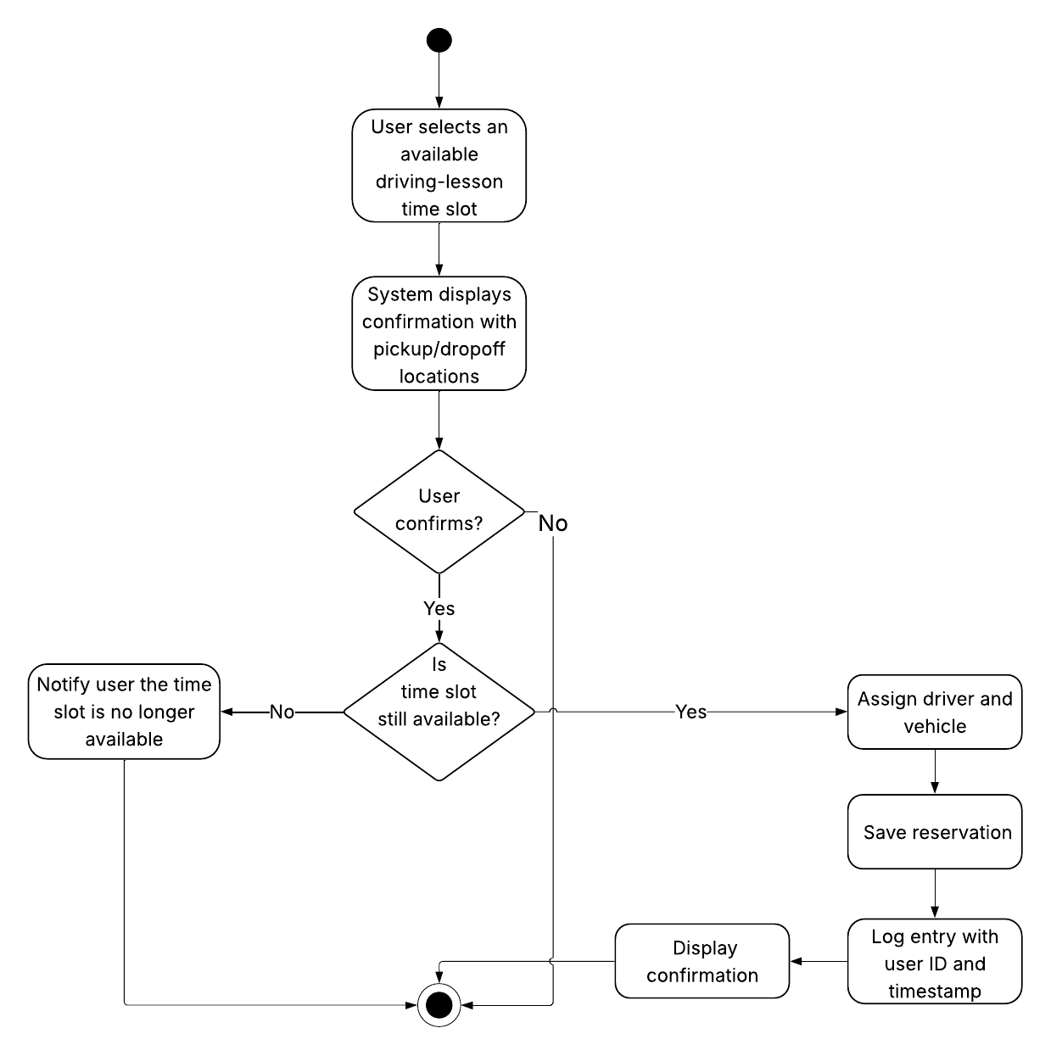

UML Sequence Diagram

The sequence diagram below models the Make Reservation interaction in detail, showing the messages exchanged between the Customer, the web interface, the application server, and the database over the lifetime of a single reservation request. The sequence captures the system's internal validation steps, including credential check, package eligibility check, driver/vehicle availability query, and the final confirmation message returned to the customer. Timestamps and change-log entries are written to the database as part of the reservation commit step to satisfy the audit trail requirement.

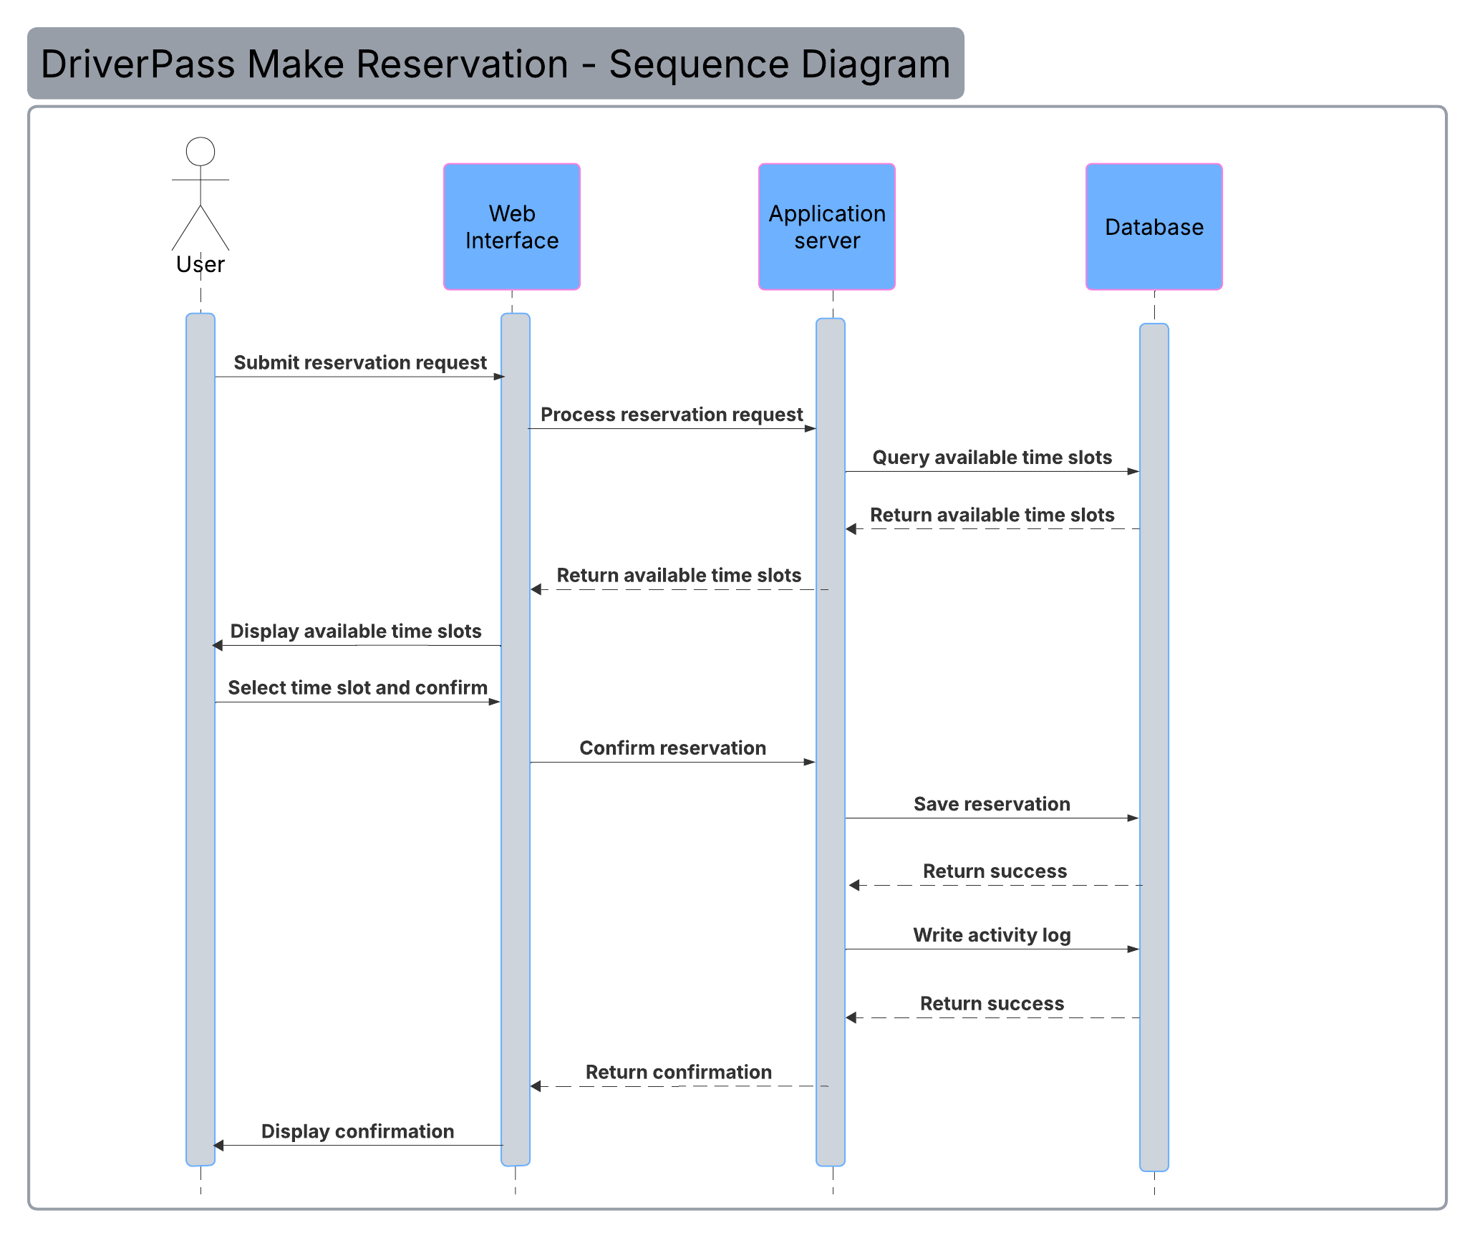

UML Class Diagram

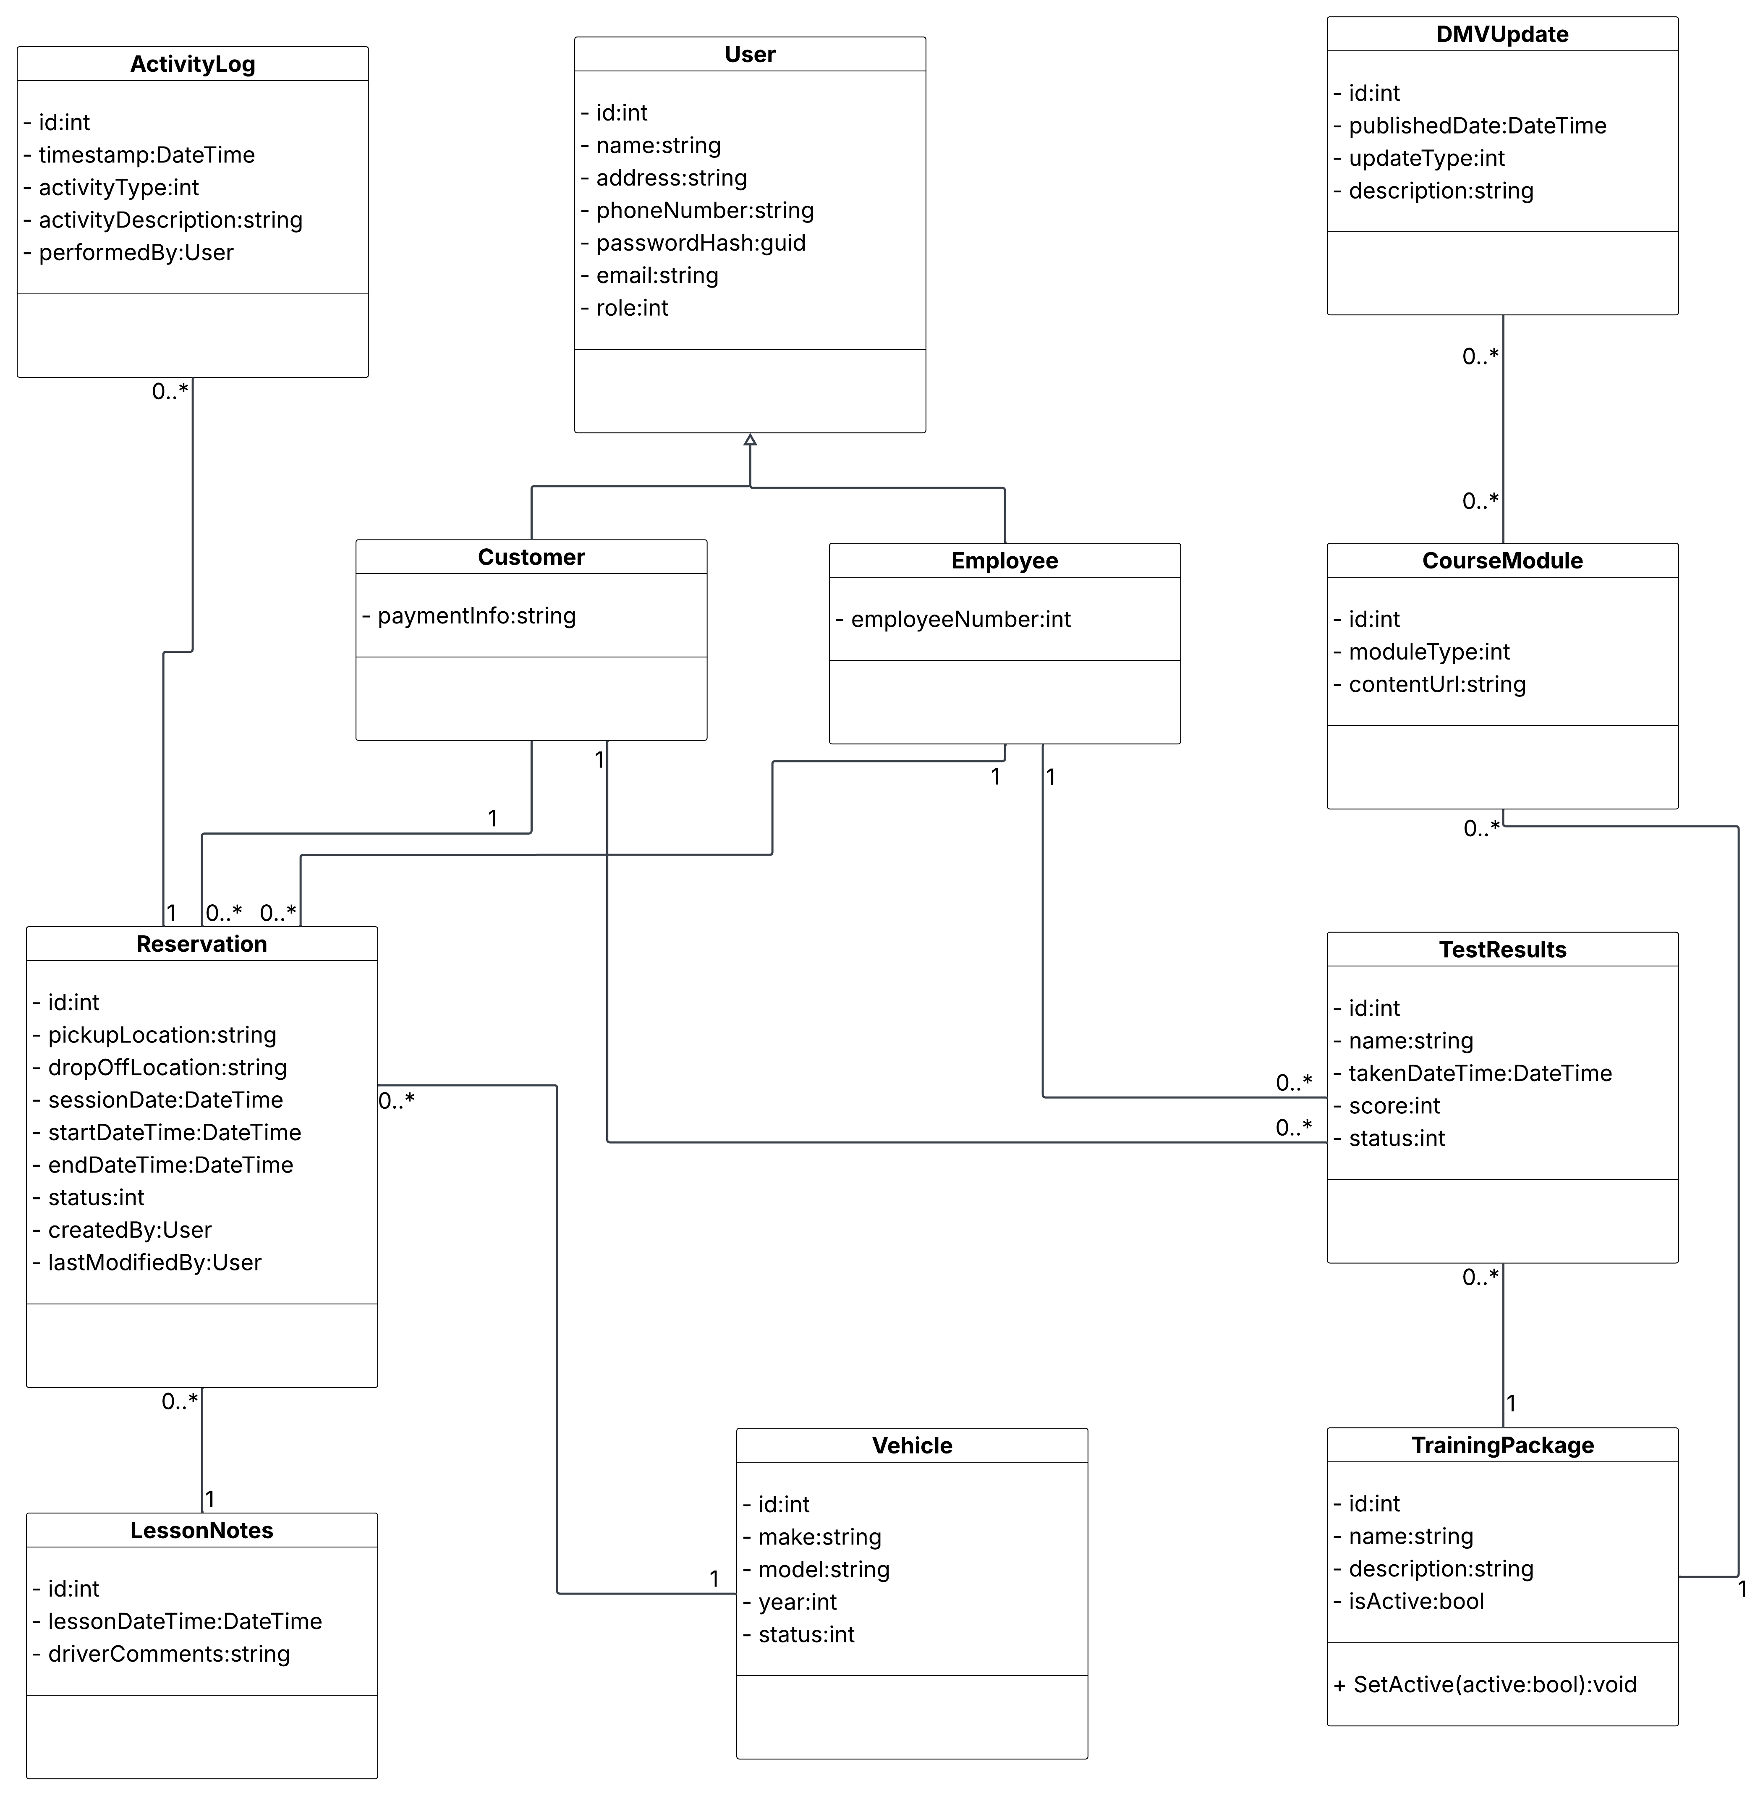

Technical Requirements

Based on the system design artifacts above and the requirements established in the Business Requirements Document, the following technical requirements describe the hardware, software, tools, and infrastructure necessary to build and operate the DriverPass system.

Infrastructure and Hosting
The system shall be cloud-hosted and delivered through a web browser, requiring no locally installed software on the part of the end user. Ian explicitly stated that DriverPass wants the system to "run off the web, preferably over the cloud" and that the company does not want to manage backups, security patching, or physical server infrastructure internally. A cloud platform such as AWS, Google Cloud, or Microsoft Azure satisfies this requirement and provides the elasticity needed to scale beyond the initial fleet of 10 cars and 10 drivers as the business grows.

The cloud provider shall be responsible for server maintenance, automated backups, security patch management, and infrastructure scaling. This is a documented assumption of the design and should be formalized in a service-level agreement with the selected provider.

Client-Side Requirements
End users require only a modern web browser (Chrome, Firefox, Safari, or Edge) on either a desktop, tablet, or mobile device. No native application is required for the initial release. Because the system is cloud-hosted, there are no operating system constraints imposed on customers, secretaries, or administrators. The system is equally accessible from Windows, macOS, Linux, iOS, and Android environments.

An active internet connection is required at all times. Sam clarified during the interview that the system will not support offline data modification, as doing so would introduce data redundancy risks. The Owner may download activity reports for offline review, but all other interactions require connectivity.

Back-End Requirements
The back end shall include a cloud-hosted relational database to store customer information, reservation records, vehicle and driver assignments, training package definitions, course module content, practice test results, lesson notes, activity logs, and DMV compliance updates. The relational model supports the associations captured in the class diagram above, particularly the multi-party relationship between Customer, Reservation, Employee (Driver), and Vehicle.

The application layer shall implement role-based access control (RBAC) to enforce the four permission tiers (Owner, Administrator, Employee, and Customer) identified in the use case diagram. The RBAC rules shall ensure that no user can access functionality outside their assigned role without an explicit privilege grant by the Administrator.

Security Requirements
All data in transit shall be encrypted using TLS 1.2 or higher. This protects sensitive customer data, including credit card numbers, personal addresses, and login credentials, from interception during transmission between the client browser and the application server.

Customer payment information (credit card number, expiration date, and security code) shall be stored in compliance with PCI DSS standards. In practice, this is best achieved by delegating card storage and processing to a certified payment processor (such as Stripe or Braintree) rather than storing raw card data in the DriverPass database directly.

The system shall enforce account lockout after a defined number of consecutive failed login attempts to mitigate brute force attacks. (The maximum allowed number of logins was never explicitly specified in the interview transcript, so I used three in my diagrams as a default.) The Administrator shall be notified automatically when an account is locked. Customers shall be able to reset their own passwords through a self-service flow without requiring Administrator intervention.

DMV Integration
The system shall provide a mechanism to receive and incorporate compliance updates from the DMV whenever new rules, policies, or sample questions are released. The design assumes the DMV exposes an API or notification service for this purpose. If no such API exists, a manual update workflow, in which an Administrator receives DMV updates and applies them to the course content, shall serve as the fallback. This assumption is documented and should be validated with the DMV prior to development.

Reporting
The Owner shall be able to generate, view, and print activity reports through the owner dashboard. Reports shall also be downloadable in formats compatible with spreadsheet tools such as Microsoft Excel (e.g., CSV or XLSX). The reporting subsystem draws from the ActivityLog class, which records every reservation creation, modification, and cancellation with a timestamp and the identity of the acting user.

